Proposal for a New Digital Innovation Promoting Sustainability at Telstra

TABLE OF CONTENTS
- Executive Summary
- Introduction
- Business Case
  - Define the Problem
  - Potential Ideas
  - Preferred Idea
  - Value Proposition
  - Product-Market Fit
  - Competitor Analysis
  - Business Model CANVAS (Appendix)
- Product Design
  - Front-end User Experience (UX) / Interface Design
  - Back-end Design
- Development and Implementation Plan
- Conclusion
- References
- Appendix

EXECUTIVE SUMMARY

KEY FINDINGS:

Telstra facing challenges in maintaining profits due to tough competition and evolving customer needs.
Strain on methods of traditional revenue generation.
Telstra has a strong infrastructure and a large customer base.

RECOMMENDATIONS:

Focus on expanding Telstra’s offerings with Cloud and Network as a service, targeting Small and Medium Enterprises.

Develop a user-friendly platform for customers to manage their Cloud and Network services.

Implement a phase plan for developing, implementing, and monitoring the Cloud and Network as a Service offering.

Harness Telstra’s strengths to lead in Australian cloud and network services market. Collaborating with other prominent platforms can lead to bigger opportunities across the globe.

INTRODUCTION
Telstra is one of the most significant telecommunication companies in Australia. The proposal encompasses a technological innovation plan for this organization, which aspires to be “Australia’s connection to the future”. In addition, this plan understands the main domains for investment and progress regarding the upcoming technologies.
Through the medium of this proposal, we will be focusing on particular ideas that are created to improve Telstra’s main enterprises, increase its customers, and further strengthen its prominence in the constantly and often fast-evolving technological domain.
The attention will be concentrated on areas that are in line with Telstra’s current strengths which can potentially empower it to achieve its future goals. At the same time, we should address the changing needs of customers within the Australian diaspora.
We will explore market trends, and examine and analyze their potential uses. Further, I will propose action steps for the organization to utilize them for maximum growth. This proposal aims to provide Telstra with a blueprint for technical leadership shortly.

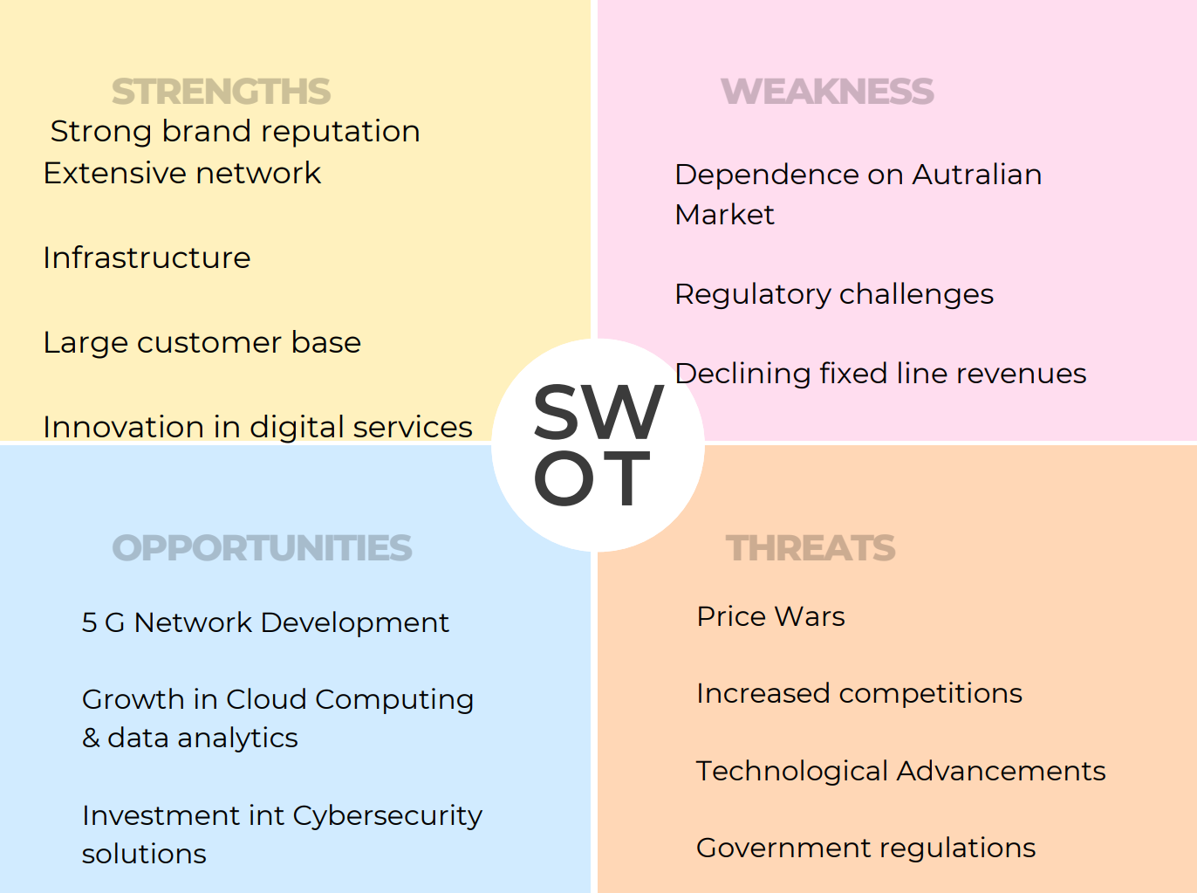

BUSINESS-CASE

DEFINING THE PROBLEM
Telstra, one of Australia's leading telecommunications providers, is facing challenges regarding maintaining profits in the long run. The Rise in competition, stiff market, and dynamic customer requirements and needs have strained traditional revenue generation methods. To ensure the sustainability and financial health of Telstra, this business case understands the need of the hour, that is to broaden and expand the range of Telstra’s offerings to its users.

POTENTIAL IDEAS
- Personalized/ Customized Bundle Services

Prepare tailored package deals catering to specific segments of its users/ customers which will help in creating a proposition of significant value encompassing more than just connectivity.

This can be achieved by using the strengths of the organization and adapting them to emerging services like smart home integration and cybersecurity solutions among others.

- Using Data Analytics

The data of Telstra’s consumer base, subject to Australia’s Data and Digital Strategy can be used to extract insights and develop appropriate strategies for businesses utilizing the transformative power of data analytics and data science. Consumer behavior trends based on the data can be used effectively for advertising in a personalized and targeted manner. In addition to this, analyzing the network traffic and usage patterns can be useful to optimize the networks.

- Cloud and Network as a Service (NaaS)
This idea addresses the increasing demand for scalable and secure Information Technology solutions, especially in the context of small and medium enterprises (many of them could later become unicorns). Telstra’s durable systems and infrastructure give a solid basis for offering cloud storage and network management services for businesses.

PREFERRED IDEA: CLOUD AND NETWORK AS A SERVICE (NaaS)
Naas provides Telstra with the most promising opportunity for profitability in
the long run because of the following reasons
- Market with great growth potential

The global NaaS market is expected to rise at the compound annual growth rate of 32.9% from 2022 to 20230. It was valued at USD 6.67 Billion in 2021.

The main reason for the demand is that it’s low cost and provides greater scalability. NaaS being deployed in various verticals like manufacturing, retail, logistics etcetera positively contributes to its growth.

- Reliable revenue stream

The stability and financial health of Telstra can be improved by subscription-based models that provide predictable and reliable revenue.

- Using existing assets

A smooth transition into the NaaS market is possible for Telstra with the required infrastructure, expertise, and its current customer base.

VALUE PROPOSITION
Small and medium enterprises will derive value from Telstra’s NaaS offering in the following ways
Saving of costs due to streamlining of IT management expenses and ending upfront hardware investments.
Scalability is the ability to adjust and align storage needs and network capacity based on business growth.
Telstra’s infrastructure and expertise in data security will provide them with protection and reliability.
Significant improvement in efficiency while they focus on core business functions as Telstra manages essential IT infrastructure.

PRODUCT-MARKET FIT

The offering aligns perfectly with the rising demand for digital (IT) solutions that are adaptable (flexible) and cost-effective. Brand recognition and the current customer base of Telstra form the basis of penetrating the market, aimed at a specific segment (SMEs) with scope for growth and a need for reliable information technology (IT) support.

COMPETITOR ANALYSIS
Big/ Major Cloud Providers: They offer comprehensive cloud services. However, they may not prioritize solutions for the specific needs of Small and Medium Enterprises.
Smaller NaaS providers: On, the other hand they might not necessarily possess the scalability and reliability of Telstra’s sturdy system and infrastructure.

TELSTRA CAN GAIN AN EDGE OVER ITS COMPETITORS BY
Developing a one-stop shop for Small and Medium Enterprises by combining cloud storage and network management solutions
Providing each Small and Enterprise customer with customized support and personalized solutions.
To further support Small and Medium Enterprise's growth, offer additional IT consulting services.

PRODUCT-DESIGN

FRONT-END DESIGN (USER EXPERIENCE/ INTERFACE)
Aim: As a business, we should do our best to ensure that users can access, deal with, and scale their Cloud and Network resources seamlessly and efficiently. Hence, the platform focuses on making a smart, intuitive, and responsive design available across a range of devices (smartphones, tablets, computers, etc.).

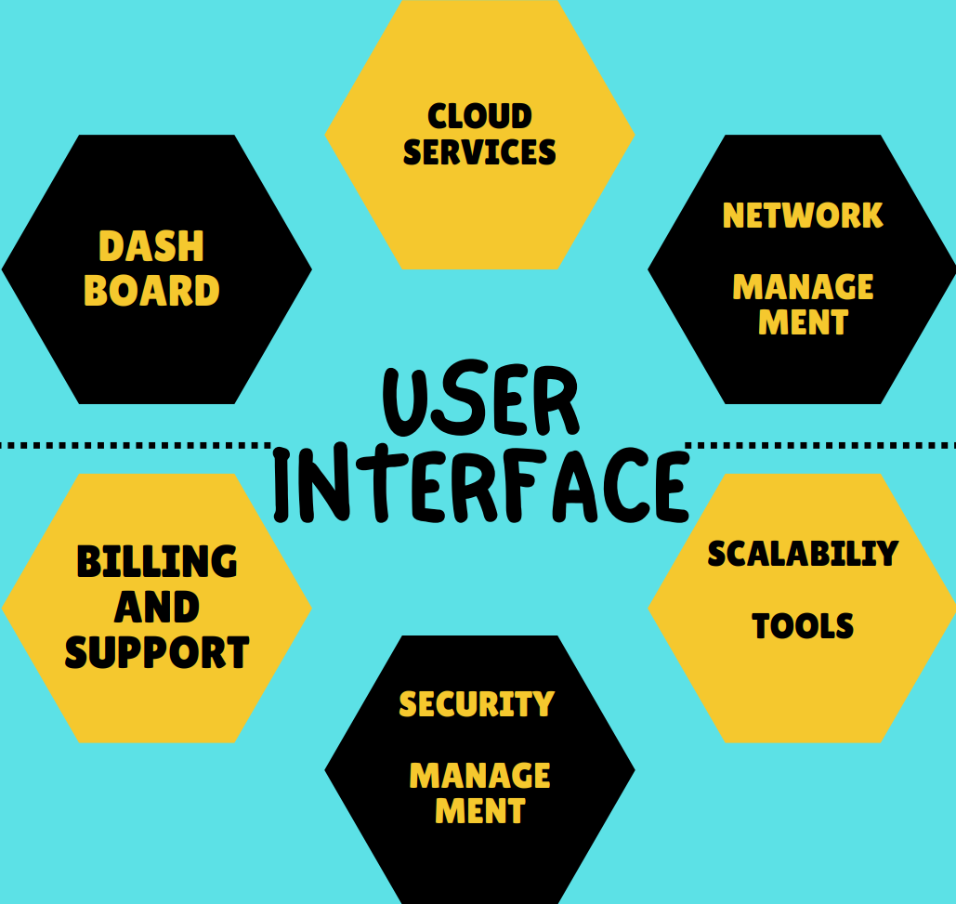

MAJOR ELEMENTS OF THE USER INTERFACE
- DASHBOARD

This is the main section where the metrics for real-time usage of Cloud resources, network performance, and billing summaries will be displayed.

- CLOUD SERVICES

Pre-configured cloud solutions classified according to business needs will be showcased in a dedicated section. This section is specially prepared so that users can have a look, select, and implement these solutions with minimum technical expertise (making it human-centric).

- NETWORK MANAGEMENT

This is a specially curated section for dealing with network connectivity. Configuring bandwidth across different locations, troubleshooting connectivity issues, and viewing network topology will become simple and accessible for the users/ customers.

- TOOLS FOR SCALABILITY

For cost optimization, users can decide on the automated scaling rules. This can be done by utilizing real-time metrics for scaling network bandwidth (up or down) and cloud resources (storing, computing, etc.) supported by intuitive controls.

- MANAGEMENT OF SECURITY

We all understand that data privacy and security are important, especially in the context of the digital age we are living in right now. Users/ customers will be able to stay vigilant for possible digital security threats by monitoring, configuring protective measures like firewalls, and defining access controls. The particular section is dedicated to dealing with security configurations for Cloud resources and Network connections.

- BILLING AND SUPPORT

This section is dedicated to activities like dealing with invoices, scrutinizing past transactions, and accessing resources for support. Users/ customers will be able to contact personnel for support directly inside the platform.

THE CUSTOMERS WILL BENEFIT FROM
THE USER INTERFACE IN THE FOLLOWING WAYS

- LOGIN

Customers will go through a small introductory onboarding process after they log in with their details to get a basic understanding of the platform’s functionalities.

- SNAPSHOT DASHBOARD

When the customers log in, the dashboard will share an overview of their Cloud and Network usage (key metrics and summary of costs) bringing them up-to-date with their details.

- SMOOTH AND EFFORTLESS NAVIGATION

Customers can browse through Cloud Services, Network Management, and other sections thanks to the clear labeling and icons.

- VISUALIZATIONS FOR INSIGHTS

A picture speaks a thousand words. The platform will harness the power of data visualization to provide insights about usage data to the customers, which can be further enhanced thanks to filters and other features for even better understanding. This can be useful in giving recommendations for optimizing resource allocation and network configuration based on usage data.

- SELF-SERVICE MANAGEMENT

The customers will be able to perform most actions by themselves like network configuration, resource scaling, and deployment of Cloud Solutions among others.

- SUPPORT INTEGRATION

Customers will be able to access resources for support easily on the platform. They can contact support personnel in Telstra or access knowledge base articles for troubleshooting

BACK-END DESIGN (WITH DATA FLOW DIAGRAM)

COMPONENTS
- USER INTERFACE (UI)

User Interface is the layer that enables users/ customers to interact with the platform.

- PLATFORM FOR CLOUD MANAGEMENT
This platform manages and deals with cloud resources based on user requests.

- SYSTEM FOR MANAGEMENT OF NETWORK

The platform is primarily dedicated to the configuration and management of the network.

- DATABASE DEDICATED TO USERS/ CUSTOMERS

This database primarily deals with storing the important details of users like access credentials.

- BILLING SYSTEM

A platform for billing and creating invoices based on customer resource usage.

- SYSTEM FOR SECURITY MANAGEMENT

Monitors threats by staying vigilant and implements measures for security like firewalls, passwords, etc.

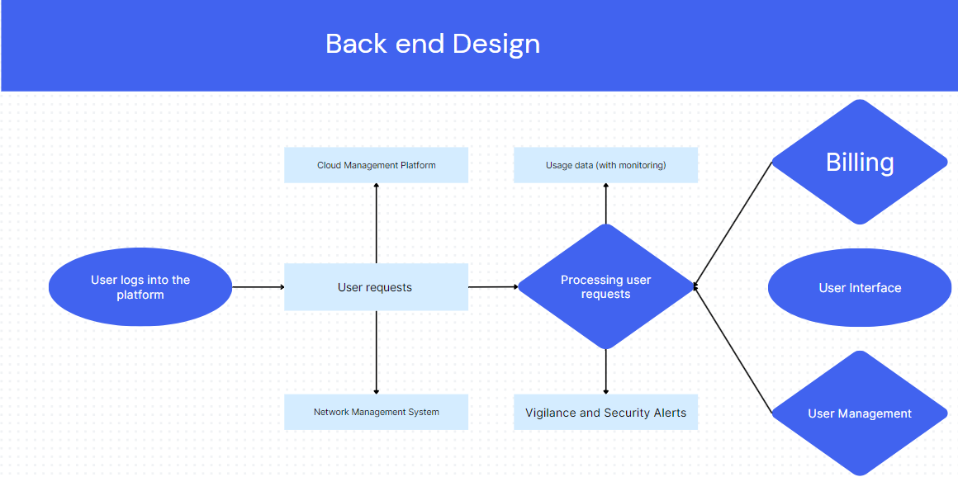

DATA FLOW

- INTERACTION WITH THE USER

The user/ customer can interact with the different features after logging into the platform using the user interface.

- USER REQUESTS

Requests for changes in network configuration, scaling of resources, or cloud services by the users are sent to the user interface.

- UI TO PLATFORM FOR CLOUD MANAGEMENT OR SYSTEM FOR MANAGEMENT OF NETWORK

Based on request type, the requests of users are sent to the relevant back-end system (Platform for Cloud Management or System for Management of Network).

- PROCESSING (PLATFORM FOR CLOUD MANAGEMENT OR SYSTEM FOR MANAGEMENT OF NETWORK)

CLOUD MANAGEMENT

Based on the choices of the users, the platform for cloud management interacts with the Cloud provider’s application programming interface (API) to manage resources like storage and computing

SYSTEM FOR NETWORK MANAGEMENT

This system interacts with network equipment to implement the necessary changes for scaling requests or changes related to network configuration.

- MONITORING THE USAGE OF RESOURCES

In the context of cloud and network services, the platform for cloud management and system for network management continuously monitor resource consumption (storage, computing, bandwidth).

- FROM USAGE DATA TO BILLING

To generate invoices, the usage data of the customer/ user is sent to the billing system.

- BILLING TO USER INTERFACE

Previous invoices and billing information are displayed within the user interface.

- VIGILANCE AND MONITORING FOR SECURITY
The system for security management actively monitors network activity and cloud resources to prevent and deal with security alerts when required.

- SECURITY ALERTS

The system sends a message to the user interface for notifying the users and taking relevant actions, if and when a security threat is detected.

- USER MANAGEMENT

Details of customers/ users like access credentials are stored and managed properly.

DEVELOPMENT AND IMPLEMENTATION PLAN

PHASE ONE: ASSESSMENT AND PLANNING (THREE MONTHS)

- SUSTAINABILITY AUDIT

To understand what measures should be taken for Telstra’s sustainability, an audit needs to be conducted to evaluate the current patterns of waste generation, utilization of network resources, and energy consumption at the data centers.

Relevant metrics include:

Kilowatt-hours of energy used at data centers.

Tons of e-waste.

Consumption rates of network bandwidth.

- DEVELOPING A STRATEGY FOR CLOUD SERVICES

Prioritizing the workloads based on cost optimization, scalability, and security requirements is important. We identify appropriate workloads for public, private, or hybrid environments. In this endeavor, developing a strategy for cloud services can be resourceful.

Relevant metrics include:

Percentage of workloads shifted/ migrated to the cloud services.

Cost savings from migrating to the cloud.

- PLAN FOR OPTIMIZING NETWORKS

To improve overall network efficiency, reduce redundant resources, and streamline network traffic we design a network optimization plan. Technologies like software define networking and network function visualization can be utilized for this purpose.

Relevant metrics:

Optimization of bandwidth utilization.

Reduction of network latency.
Network hardware footprint reduction.

PHASE TWO: IMPLEMENTATION (TWELVE MONTHS)

- CLOUD MIGRATION

Follow a secure and well-defined process for migration of prioritized workloads to chosen cloud environments. Utilize disaster recovery protocols and data security measures.

Relevant metrics:

Count of the workload that was migrated to the cloud.

Downtime during the migration process.

- NETWORK OPTIMIZATION EXECUTION

Deployment of technologies like software-defined networking and network function visualization for reducing congestion in the network, automating the management of the network, and improving the allocation of resources with the overall aim being to implement the network optimization plan.

Relevant metrics:

Network uptime optimization (improvement).

Network management time reduction.

Reduction in power consumption of the network.

- TRAINING OF EMPLOYEES

It is important to train employees of the organization on the new cloud infrastructure and tools for network management. Also, ensure efficient utilization of new technologies and smooth adoption by the users/ consumers.

Relevant metrics:

Satisfaction of employees regarding training programs.

Proficiency of users/ customers in cloud and networking tools.

PHASE THREE: MONITORING AND OPTIMIZATION (ONGOING)

- MONITORING OF PERFORMANCE

Identify and work on opportunities for cost reduction, while using data analytics tools for tracking consumption of resources.

Actively monitor metrics of cloud and network performance to find areas for further improvement and optimization.

Relevant metrics:

Return on Investment from optimization of cloud and network

Cloud and network performance metrics like latency, uptime, and cost.

- SUSTAINABILITY REPORTING
Reducing the environmental impact through cloud and network optimization efforts is important. Hence, a comprehensive sustainability reporting framework needs to be developed to track Telstra’s efforts regarding sustainability.

Relevant metrics:

Data center energy consumption reduction.

Reduction of carbon footprint related to the network.

CONCLUSION

Cloud and Network as a Service emerges as the best-recommended path for Telstra’s sustainable growth from this proposal. This organization’s current infrastructure places it in the perfect position to capitalize on trends in the Cloud and network as a Service market globally.

To establish itself as a key player in the long run, Telstra can begin by providing Small and Medium Enterprises (SMEs), with scalable and secure IT solutions. This will help develop long-term customer relationships and recurring revenue streams, especially based on subscriptions.

The front-end design empowers customers to manage their resources effectively by prioritizing ease of use. Meanwhile, back-end design focuses on ensuring data security and operations happen smoothly.

The development and implementation plan consists of three phases beginning with development and planning, followed by implementation and finally culminating in monitoring and optimization. Telstra can maximize its return on investment while achieving its sustainability goals empowered by the data-driven approach.

Overall, Telstra can solidify its position as a leader in Australian telecommunications while contributing to a green future, by embracing Cloud and Network as a Service.

REFERENCES

Grand View Research (2023). Network as a Service Market Report. https://www.grandviewresearch.com/industry-analysis/network-as-a-service-market-report

Greenhouse Gas Protocol. https://ghgprotocol.org/

RightScale. (n.d.). RightScale Components vs. Cloud Resources. https://docs.rightscale.com/cm/pas/rightscale_components_vs_cloud_resources.html

SDxCentral. https://www.sdxcentral.com/
Cloud Security Alliance. https://cloudsecurityalliance.org/
Open Networking Foundation. https://opennetworking.org/
Gartner. (n.d.). Gartner IT Infrastructure, Operations & Cloud Summit. https://www.gartner.com/en/conferences/na/infrastructure-operations-cloud-us
- Global Reporting Initiative.

- https://www.globalreporting.org/

APPENDIX
BUSINESS MODEL CANVAS

CUSTOMER SEGMENT

Small and Medium Enterprises

VALUE PROPOSITIONS
- COST SAVINGS:
Reduced IT management expenses and elimination of upfront hardware investments.
- SCALABILITY:
Ability to adjust storage needs and network capacity based on business growth.
- SECURITY AND RELIABILITY:
Protection and reliability are backed by Telstra's robust infrastructure and
expertise in data security.
- IMPROVED EFFICIENCY:
Increased focus on core business functions as Telstra manages essential IT infrastructure.

CHANNELS
- Telstra website and sales channels
- Partnerships with industry associations and technology resellers

CUSTOMER RELATIONSHIPS
- Dedicated account managers for personalized support
- Self-service portal for managing resources and billing
- Online knowledge base and support resources

REVENUE STREAMS
- Subscription-based pricing for cloud storage and network management services
- Value-added services such as IT consulting and security assessments

KEY RESOURCES
- Cloud infrastructure and data centers
- Network management platform
- Team of cloud and network engineers
- Customer support personnel

KEY ACTIVITIES
- Marketing and promoting NaaS offerings
- Onboarding and provisioning cloud and network services
- Managing and maintaining cloud infrastructure and network
- Providing customer support and technical assistance

KEY PARTNERSHIPS
- Cloud providers (for additional cloud services)
- Technology vendors (for network equipment and software)

COST STRUCTURE
- Cloud infrastructure costs
- Network management platform costs
- Salaries of cloud and network engineers
- Customer support costs
- Marketing and sales expenses

